
Family and Community Engagement
Project Charter
2016-2017

This project supports the following
Long-Range Goals:

x Long-Range Goal 1
Long-Range Goal 2
Long-Range Goal 3
x Long-Range Goal 4
Long-Range Goal 5
Long-Range Goal 6
Long-Range Goal 7

Strategic Plan Performance Measure(s) Addressed:
Goal 1: Increase student achievement resulting in improvements for each school’s learning gains, grade level proficiency rates, graduation rates, and school grade designations of A, B or C.
Goal 4: Provide equity and excellence of education by increasing overall performance and eliminating the gaps between minority and non-minority student outcomes by reducing the disparity in graduation rates, proficiency scores on assessments, participation and performance in accelerated courses, disciplinary infractions, and placement in Exceptional Student Education programs.

Project Short Description
Research has clearly stated that when families and communities are engaged students are more likely to graduate from high school with college and career readiness, increase their academic performance, take rigorous courses, and attend school regularly. The Family and Community Engagement Project is designed to: (1) increase the number of family engagement events link to learning, (2) establish systems of support for students, families and schools, (3) provide resources to strengthen students, schools, families and communities, and (4) develop a way of work to embrace and co-partner with our community stakeholders.
Desired Results
(Insert 3 to 5 desired results that describe the future and how it will be different (better) as a result of the work completed by this project. Think ahead, with the end in mind, to the real benefits to be derived from this work.)

1 | Every school has an effective family engagement team.
2 | All family engagement efforts are result-oriented as opposed to event oriented.
3 | A sustainable infrastructure is in place to provide tools and resources to our families to support student learning.
4 | Developed organizational system of community integration by which all stakeholders are integral partners in student learning.
5 | A monitoring and accountability system in place to determine effective engagement between families, community and school staff.

Deliverables
(List the key things that this project will create or deliver – e.g., deliverables. The deliverables should be nouns and should be sufficient to bring about the Desired Results described above):
1 | All school staff/community members will be trained in Dual-Capacity Framework for Family and Community Engagement.
2 | Schools’ family engagement plans will be developed, reviewed, and implemented by District and school based action teams.
3 | Community agencies and organization will collaborate with District to provide tools and resources for students, schools, and families.
4 | Community outreach efforts for input, collaboration, and transparency will be systemized.

Project Organization
Role | Description | Assignment
Sponsor (member of Executive Staff) | Has ultimate authority over and is responsible for a project and/or a program, its scope and deliverables. | Lori Matway, Associate Superintendent of Student Services
Project Manager | Develops and maintains project plan and project schedules, executes project reviews, tracks and disposes of issues and change requests, manages the budget, and is responsible for overall quality of the deliverables. | Valerie Brimm, Director of Strategic Partnerships
Project Team | Is responsible for performing the activities necessary for implementation of the project. | Valerie Brimm  Sheila Kane  Dr. Felita Grant  Brittany Daniels  Johnetta Haugabrook  Merlande Petitbois  Natasha Karac  Sandra Hopkins  Shana Rafalski  Former Mayor David Archie
Key Stakeholders | Provides expert understanding of their organization, and represents area for which the project is intended to support/serve. | Executive leadership team consisting of top leadership that represent key departments to impact engaging families and community

Project Schedule Summary
The table below is to be used for all PMOC projects as follows:
- Step I – Project Plan (see table 1 below)
- Identify one project’s deliverable (noun) in the row that is highlighted in each table. You can add additional rows to accommodate all of the project’s deliverables. The rows beneath each deliverable are for the detailed tasks.
- Identify the detailed Action Steps to produce each deliverable in the rows beneath the deliverable.
- For each Action Step, indicate a date when the work will begin and when the work will be finished. Additional rows can be added as necessary.
- Step II –Monthly Status Report (see table 2 below)
- Indicate the status for each activity and the actual completion date.
- Identify any issues that the project is dealing with in the rows at the bottom of the table.
- The monthly report is to be submitted to the Sponsor and will reflect work completed in the previous month.

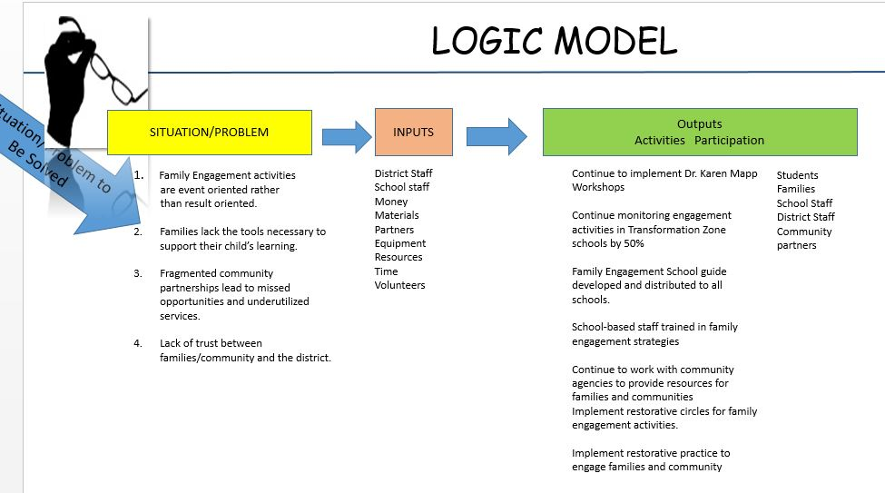
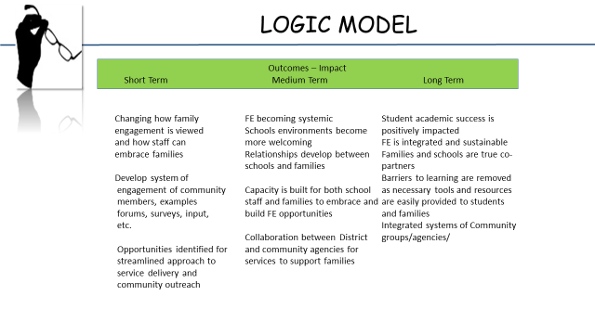

 |  |  |  |  | 8/1/2016 – Table 1
Project Schedule/Status Report
Family and Community Engagement Project |  | Submitted by: Valerie Brimm
Item # | Deliverable(s) and Action Steps | Responsible Person | Start Date | Projected End Date | Status  (%complete) | Actual Completion Date
1.0 | All school staff/community members will be trained in Karen Mapp’s Dual Capacity Framework.
1.1 | Karen Mapp Workshop Series #1 training to 26 schools | Brimm | 5/16/16 | 5/20/16 | 100% | 5/20/16
1.2 | Workshop Series #2 training to 26 schools | Brimm | 9/19/16 | 9/23/16
1.3 | School Resource Guide developed for all schools | Kane/ Brimm | 4/1/16 | 8/16 | 75%
1.4 | School Resource Guide delivered to schools that are not attending Karen Mapp series | Kane | 8/16
1.5 | School Family Engagement Action teams are formed and begin executing action plans
1.6 | Workshop Series #3 training to 26 schools | Brimm | 10/16 | 10/16
1.7 | Develop a Family Engagement workshop covering highlights from the Karen Mapp series and offer through PD | Kane | 10//16 | 12/16
1.8
1.9
Action Step # | Issue(s) | Date Presented | Resolution |  |  | Date Resolved

 |  |  |  |  | 8/1/2016 – Table 1
Project Schedule/Status Report
Family and Community Engagement Project |  | Submitted by: Valerie Brimm
Item # | Deliverable(s) and Action Steps | Responsible Person | Start Date | Projected End Date | Status  (%complete) | Actual Completion Date
2.0 | Schools’ family engagement plans will be developed, reviewed, and implemented by District and school based action teams.
2.1 | Schools trained through Karen Mapp Workshop series develop Family Engagement Action Plans. | Brimm | 9/19/16 | 9/23/16
2.2 | Schools other than those participating in Karen Mapp Workshop series are provided a framework to develop their Family Engagement Action plans. | Kane | 9/26/19 | 10/7/16
2.3 | School Family Engagement teams forward Action Plans to District. | Kane | 10/16 | 10/16
2.4 | District reviews and provides input to school Family Engagement Action Plans. | Kane | 10/16 | 11/16
2.5
2.9
Action Step # | Issue(s) | Date Presented | Resolution |  |  | Date Resolved

 |  |  |  |  |  | 8/1/2016 – Table 2
Project Schedule/Status Report
Family and Community Engagement Project |  | Submitted by: Valerie Brimm
Item # | Deliverable(s) and Action Steps | Responsible Person | Start Date | Projected End Date | Status  (%complete) |  | Actual Completion Date
3.0 | Community Agencies and organizations will collaborate with District to provide tools and resources for students, schools, and families.
3.1 | JWB funded Suncoast Center Mental Health Specialists and PEHMS Navigators meet to review expectations, roles and responsibilities for the Transformation Zone schools. | Brimm | 8/2/16 | 8/2/16 | 100% |  | 8/2/16
3.2 | Same group as above meets regularly (monthly?) to network and share learnings, revise expectations and procedures | Brimm
3.3
3.4
3.5
Action Step # | Issue(s) | Date Presented | Resolution |  |  |  | Date Resolved

 |  |  |  |  |  | 8/1/2016 -Table 3
Project Schedule/Status Report
Family and Community Engagement Project |  | Submitted by: Valerie Brimm
Item # | Deliverable(s) and Action Steps | Responsible Person | Start Date | Projected End Date | Status  (%complete) |  | Actual Completion Date
4.0 | Community outreach efforts for input, collaboration, and transparency will be systemized.
4.1 | Develop a schedule for quarterly forums to report out and gather input | District Leaders | August/16 | Dec 2016
4.2 | Create a digital system to send information to stakeholders for transparency and input | Strategic  Communication | August/16 | Dec 2016
4.3 | Create a website page for incoming questions and answers regarding major issue in the district | Brimm/Demorris | August/16 | Dec 2016
4.4 | Implement Restorative Circles for community transparencies | Brimm | August/16 | June 2017
4.5
4.6
4.8
4.9
Action Step # | Issue(s) | Date Presented | Resolution |  |  |  | Date Resolved

Project Budget Summary
[The budget and costs reflected in the Project Plan should account for all resource labor, hardware, software, facilities, etc. required to achieve the stated scope and objectives.]
Project Budget Summary
Budget Categories |  | Amount | Amount  [ funding source] | Amount  [funding source]
a | Internal Resource Labor (estimate the number of hours that will be required to complete the project) | ______ hours
b | External (Contract) Resource Costs  *List provider(s) / amount(s)  Ex: Transcend / $35,000 | $ XXX (total contract costs)
c | Materials and Supplies (please list) | $ XXX
d | Employee Expenses (i.e., travel, registration fees, etc.) | $ XXX
e | Training (please list) | $ XXX
f | Other (please list) | $ XXX
TOTAL (sum rows b-f) |  | $ XXX | $ XXX | $ XXX

Approved by PMOC: Date:

Team Member Signature
(Instructions: Hold a review of the project plan with your team members and obtain their agreement to participate. Each team member’s signature represents his or her agreement to participate in this effort.)
Team Member - Agreement to Participate
Organization / Rep | Signature | Date
Lori Matway
Valerie Brimm
Sheila Kane
Dr. Felita Grant
Brittney Daniels
Johnetta Haugabrook
Merlande Petitbois
Natasha Karac
Sandra Hopkins
Shana Rafalski
Former Mayor David Archie

